**Real-time alerts from AI-enabled camera traps using the Iridium satellite network: a case-study in Gabon, Central Africa**

Robin C. Whytock1, Thijs Suijten2, Tim van Deursen2, Jędrzej Świeżewski3, Hervé Mermiaghe4,12, Nazaire Madamba5, Narcisse Mouckoumou5, Joeri A. Zwerts6, Aurélie Flore Koumba Pambo5, Laila Bahaa-el-din7, Stephanie Brittain8, Anabelle W. Cardoso9, Philipp Henschel10, David Lehmann5, Brice Roxan Momboua5, Loïc Makaga5, Christopher Orbell1,10, Lee J.T. White1, 11,12, Donald Midoko Iponga12, Katharine A. Abernethy1,12

*Robin C. Whytock and Thijs Suijten contributed equally to the manuscript.*

1 Faculty of Natural Sciences, University of Stirling, FK9 4LA, UK

2  Hack the Planet, Q42, The Netherlands

3 Appsilon AI for Good, Warsaw, Poland

4  School of Architecture and Environment, Department of Landscape Architecture University of Oregon, Eugene, OR 97403-5249 US

5 Agence Nationale des Parcs Nationaux, Libreville, Gabon

6 Utrecht University, Heidelberglaan 8, 3584 CS Utrecht, The Netherlands

7 School of Life Sciences, University of KwaZulu-Natal, South Africa

8 University of Oxford, Department of Zoology, Oxford, UK

9 Department of Ecology and Evolutionary Biology, Yale University, New Haven, CT 06520, USA

10 Panthera, 8 West 40th Street, 18th Floor, New York, NY 10018, USA

11 Ministry of Water and Forests, Boulevard Triomphal, Libreville, Gabon

12 Institut de Recherche en Ecologie Tropicale, CENAREST, BP 842 Libreville, Gabon

**Abstract**

1. Efforts to preserve, protect, and restore ecosystems are hindered by long delays between data collection and analysis. Threats to ecosystems can go undetected for years or decades as a result. Real-time data can help solve this issue but significant technical barriers exist. For example, automated camera traps are widely used for ecosystem monitoring but it is challenging to transmit images for real-time analysis where there is no reliable cellular or WiFi connectivity.
2. We modified an off-the-shelf camera trap (BushnellTM) and customised existing open-source hardware to rapidly create a ‘smart’ camera trap system. Images captured by the camera trap are instantly labelled by an artificial intelligence model and an ‘alert’ containing the image label and other metadata is then delivered to the end-user within minutes over the Iridium satellite network. We present results from testing in the Netherlands, Europe, and from a pilot test in a closed-canopy forest in Gabon, Central Africa.
3. Results show the system can operate for a minimum of three months without intervention when capturing a median of 17.23 images per day. The median time-difference between image capture and receiving an alert was 7.35 minutes. We show that simple approaches such as excluding ‘uncertain’ labels and labelling consecutive series of images with the most frequent class (vote counting) can be used to improve accuracy and interpretation of alerts.
4. We anticipate significant developments in this field over the next five years and hope that the solutions presented here, and the lessons learned, can be used to inform future advances. New artificial intelligence models and the addition of other sensors such as microphones will expand the system’s potential for other, real-time use cases including wildlife tourism, real-time biodiversity monitoring, wild resource management and detecting illegal human activities in protected areas.

**Introduction**

Automated camera traps (or ‘trail cameras’) are used to detect and survey wildlife, and by conservation managers to identify ecosystem threats (Bessone et al., 2020; Hobbs & Brehme, 2017; Wearn & Glover-Kapfer, 2019). Many commercial models are available and cameras can also be easily custom-built using off-the-shelf components (Droissart et al., 2021).

Network-enabled camera traps, which send captured images to users in real-time, are now commercially available but typically need access to a reliable broadband cellular network connection. In many countries, however, cellular network coverage is still limited and is often unreliable, causing ‘data poverty’ (Leidig & Teeuw, 2015). Cellular network coverage is also usually focused on human population centres, which might be far from areas of ecological or conservation interest. As a result, camera traps with network connectivity are rarely deployed at scale in network-limited landscapes.

Beyond network connectivity, another challenge limiting the usefulness of camera traps for timely decision-making has been extracting relevant information from the large volume of images generated, or “image labeling”. Solutions to labeling large image databases range from using dedicated software that speeds up manual image labeling, to large-scale community science projects and the use of artificial intelligence algorithms (Beery et al., 2019; Swanson et al., 2016).

The precision and accuracy of the latest artificial intelligence algorithms for image labelling now approach or match human experts for some species. However, these algorithms typically require powerful computing resources either based on ‘the cloud’ or locally using expensive hardware (Norouzzadeh et al., 2018; Tabak et al., 2019; Whytock et al., 2021). Recent developments in the field of ‘edge computing’ allow artificial intelligence algorithms to be deployed on microcomputers with relatively low computing and electrical power requirements. It is therefore now possible to integrate artificial intelligence and camera trap hardware for deployment in the field.

Here, we present a design for a ‘smart’ camera trap system that integrates artificial intelligence with a popular off-the-shelf camera trap for real-time alerts over the Iridium satellite network. We present results from systematic testing in the Netherlands and a field-pilot in Gabon, Central Africa to evaluate the system’s capabilities. Our aim is not to provide a blueprint for a finished ‘tool’, such as the Audiomoth bioacoustic recorder (Hill et al., 2018), but to provide insights and guidance into how we solved the significant technical challenges posed by tuning a large number of field, software, hardware and artificial intelligence parameters to create a field-ready system.

**Methods**

*System overview*

Our objective was to create a robust, field-ready system that could (1) provide real-time alerts from camera traps at an affordable cost, (2) be deployed in the most rural landscapes without existing GSM, Long Range radio (LoRa) or WiFi coverage, (3) function without installing additional infrastructure such as communication towers, base stations or meshed networks, (4) be easily deployed by users who do not have a specialist background in using artificial intelligence-enabled technology and (5) avoid re-inventing existing technology (e.g. camera traps), thus allowing us to solve the problem within a relatively short time frame.

Our solution was to modify a standard BushnellTM camera trap by adding additional hardware allowing it to communicate wirelessly (Figure 1; Figure S1) with separate, self-contained computing resources installed nearby - which we named the ‘smart bridge’ (Figure 1; Figure S2). The smart bridge is based on an earlier prototype designed to take photographs of wild penguins (https://github.com/IRNAS/arribada-pmp), and provides an intelligent link, or ‘bridge’, between the camera trap and the end user.

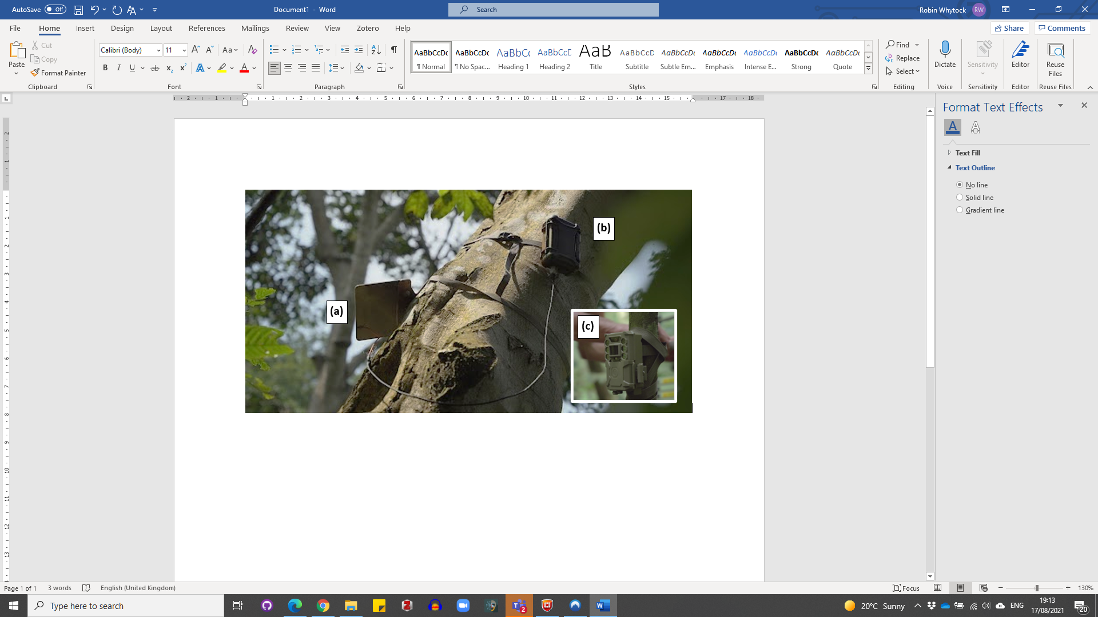

**Figure 1.** System deployed in the field showing the solar panel (a) and smart bridge attached to a tree approximately 6 m above ground level (b). The BushnellTM camera trap is installed at ground level approximately 10 m away from the smart bridge (c).

We customised the camera trap by installing a microcontroller with LoRa capabilities based on the OpenCollar Lion Tracker (<https://github.com/IRNAS/smartparks-lion-tracker-hardware>) (Figure S1). Instead of the standard secure digital (SD) card, we used a WiFi-enabled SD card. When an image is captured by the camera trap, the LoRa board in the camera alerts the smart bridge and activates the WiFi SD card, creating a local WiFi network. The smart bridge boots a Raspberry Pi Compute Module 4 that joins the WiFi network and retrieves the image or images from the camera. The species contained in the image are then identified using an artificial intelligence algorithm for species classification (Supplementary Material). The species and metadata associated with the image (time, date, location) and smart bridge sensor data (internal temperature, humidity and power status) are finally transmitted in an encoded message from the smart bridge to a web-based application running in the cloud (Google's App Engine). These data were then instantly provided to the end-user as WhatsAppTM messages and web-based alerts using the EarthRanger software platform (www.earthranger.com). Data are sent over the Iridium satellite network, which provides global coverage within minutes. To save power, the Raspberry Pi then shuts down and the smart bridge enters a low-power sleeping mode. Pairing between the camera and smart bridge is automatic and requires no user input or setup. A diagram of the system logic is shown in Figure 2. Full technical details on the system design, components used and the artificial intelligence algorithm are given in the Supplementary Material.

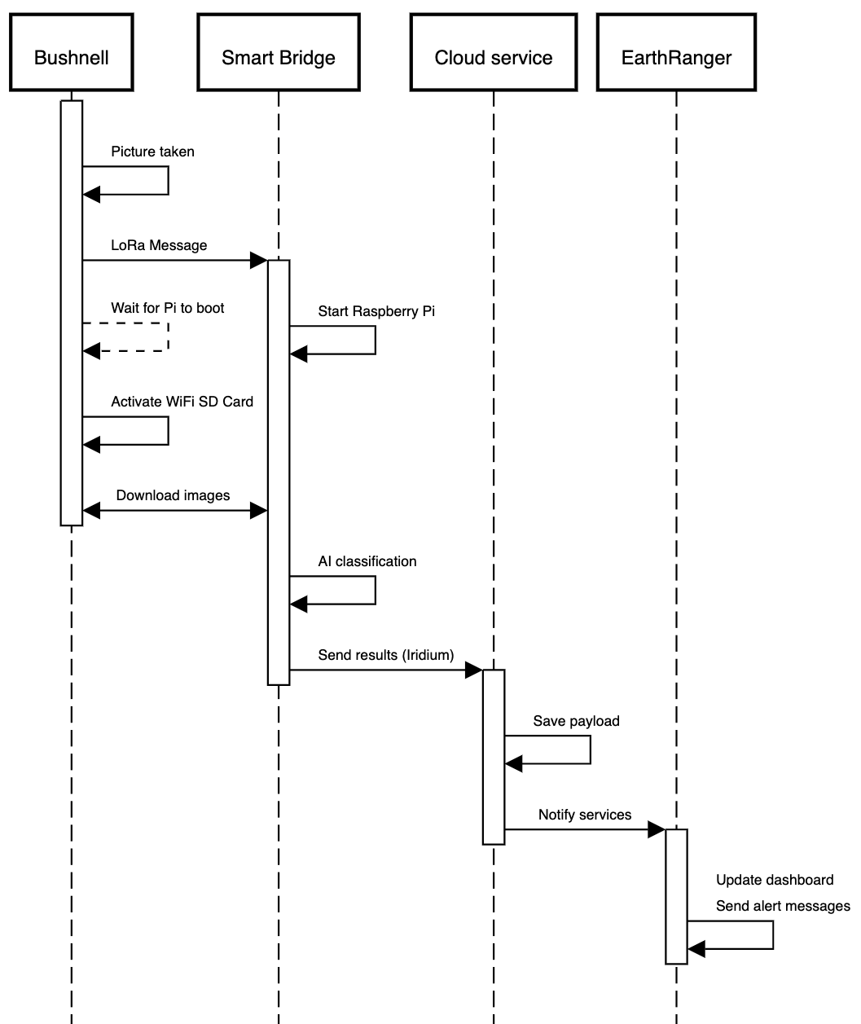

**Figure 2.** Diagram showing the stepwise logic between the BushnellTM camera trap capturing an image and sending an alert via the smart bridge. Total duration of the entire process is approximately five minutes under optimal conditions.

**Case study and field test**

Real-time alerts from cameras have many potential applications but our interest was testing if they could be used to help manage human-elephant interactions during crop depredation, in Gabon, central Africa. We therefore partnered with Gabon’s Agence Nationale des Parcs Nationaux to test the camera’s ability to detect elephants and send real-time alerts to ANPN ecoguards over WhatsAppTM in two locations. The first location was the Station d’Etudes des Gorilles et Chimpanzés (SEGC) in Lopé National Park, where elephants are common in the surrounding area. The facilities at the research station allowed us to test the system under controlled but realistic conditions (elephants regularly enter the station grounds). The second location was Kazamabika village, in the northern edge of Lopé National Park, where communities have established farms and work closely with ANPN to find solutions to human-elephant conflict.

*Field testing*

We tested five systems under different settings for a combined total of 72 days (Table 1). The artificial intelligence model was trained on three classes relevant to the pilot tests, which were elephant, human or ‘other’ (Supplementary Material). Camera locations were chosen to test (a) how the position of the smart bridge and vegetation structure (e.g. forest canopy cover) affected data transmission and satellite connectivity, (b) how far the smart bridge could be installed from the camera, (c) how well the solar panel functioned under different light levels, and (d) how well the artificial intelligence algorithm performed with different camera backgrounds (open areas, farmland and forest). We chose the testing locations based on qualitative differences in vegetation structure, light availability and image background (Table 1). In summary, the smart bridge and solar panel were installed together on a tree 2 - 6 m above ground level at a distance of 5 - 20 m from the camera trap. Camera traps were installed on a tree approximately 40 - 50 cm above ground level, perpendicular to and approximately four metres from the centre of well-used elephant paths.

We compared results from field testing with benchmark data from two systems operated in a private urban setting in the Netherlands for three months during the development stage.

**Table 1.** Description of test locations and field conditions with qualitative descriptions of light availability (Light: low, medium, high), distance between camera and smart bridge (Bridge: near < 5 m, moderate 5 - 10 m, far 10 - 20 m), the positioning of the Smart Bridge (Bridge position) and image background (considered important for artificial intelligence performance).

|  |  |  |  |  |  |  |
| --- | --- | --- | --- | --- | --- | --- |
| **Site name** | **General description** | **Days** | **Light** | **Bridge distance** | **Bridge position** | **Image background** |
| SEGC | Research station with buildings and open short grassland. No forest cover. | 7 | High | Near | Approximately 2 m above ground level under the canopy of a small shrub. | Open grassland, buildings |
| Forest West | Closed canopy forest with vegetated understory. Moved a short distance to a new location due to false positives from the artificial intelligence algorithm (see Results). | 15 | Low | Moderate | Approximately 5 m above ground level on the trunk of a tree approximately 15 cm diameter at breast height (DBH) | Green vegetation in the background and a large tree crossing the left of the image. |
| Forest East | Closed canopy forest with open understory | 18 | Moderate | Far | Approximately 5 m above ground level on a large tree trunk. | Background of large woody lianas, a fallen tree and little vegetation. Brown forest floor. Little green vegetation. |
| Kazamabika | Village edge. Closed canopy forest beside a small river, | 17 | High | Far | Approximately 5 m above ground level on a large tree trunk. | Green vegetation with some brown forest floor |
| Cayette | Forest fragment of secondary growth. With a rather open understory. | 15 | Low | Far | Approximately 2 m above ground level on a small tree. | Green vegetation with some brown forest floor. |

*Data analysis*

To evaluate the speed at which alerts were transmitted and received, we calculated the median time-difference in minutes between image capture and receipt of the alert by the back end for each location individually, and for all stations. For each of the test locations we also created time-series plots showing changes in smart bridge power during deployment. The BushnellTM camera power was also monitored during tests in the Netherlands but not during the field testing.

We assessed artificial intelligence model ‘field’ performance (precision, recall, accuracy and F1 score (Kuhn, 2020)) on the newly captured images by comparing the artificial intelligence-generated image labels with ‘expert’ labels. Expert labels were created after the field test by first labeling the captured images using the Mbaza AI software (Whytock et al., 2021) and manually validating all results (co-author RW).

During field testing we observed that, within a given image sequence of elephants (i.e. a number of images taken during the same image capture event), the first and last images could be mislabelled when only a small part of the elephant was visible. We therefore tested if (a) a simple vote-counting approach (i.e. counting the most frequently predicted top-one label in an image series) could improve predictions on an ‘event’ (time window containing an image series), and (b) if excluding images below a ‘confidence’ (softmax value) threshold from the artificial intelligence model before vote counting could improve event prediction accuracy. Events were defined as a series of images taken within an independent 30-minute time window. Softmax thresholds were from 0 to 0.9 in 0.1 intervals. In some instances, vote counting resulted in a tie between the number of votes for each class. In these cases, we chose ‘elephant’ if it was among the ties, or otherwise chose the label ‘other’.

**Results**

A total of 814 images were captured during the field test (Table S2) and alerts for 588 images were received by the backend. Of the 226 alerts not received, 72 were from Cayette, which was not able to send any alerts due to the position of the smart bridge (2 m above ground level) and 154 were from Forest East because the smart bridge unexpectedly ran out of battery after just six days. This was caused by a problem with the charging circuit and was inconsistent with tests in the Netherlands, which achieved > 3 months of battery life (see *Battery life* for further details). We removed a further 17 images which had no timestamp (human error during camera setup) and which could not be used to evaluate alert time delays, leaving *n* = 571 alerts from four systems for the analysis.

*Alert times*

There was a median 7.35 minutes time difference between capturing an image and sending an alert (*n* = 4 camera stations). Median, minimum and maximum alert times are given in Table S3 for each location. Of the four systems, Kazamabika had the slowest median alert time (306.3 min). A total of 296 (52%) of alerts were received within 15 minutes or less (Figure 3, Figure S3).

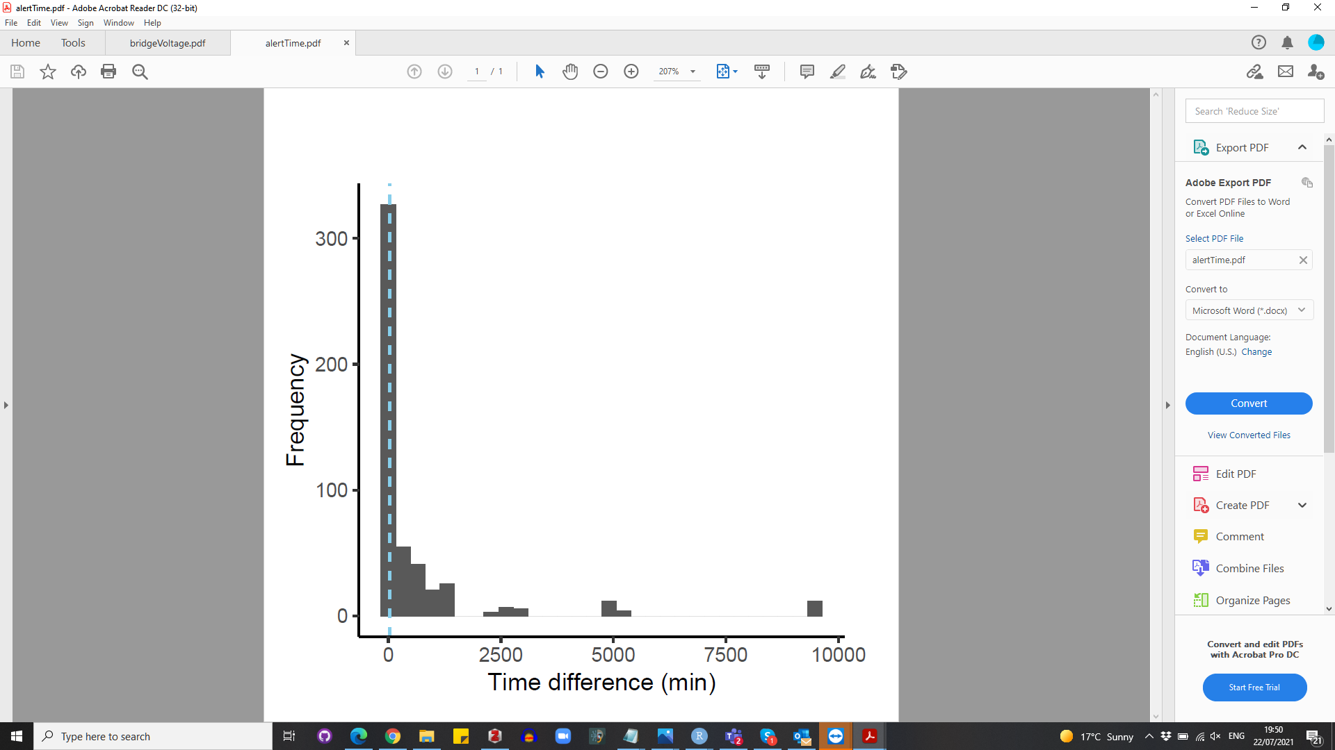

**Figure 3.** Histogram showing time difference between image capture and alert transmission time. The dashed line shows the median alert time of 7.35 minutes.

*Battery life*

Tests in the Netherlands showed that even with a median of 17.23 image captures per day (range 0 - 40), the systems could operate continuously during the winter under low sunlight for a minimum of three months (Figure 4). During field testing in Gabon, we found mixed results (Figure 5) and one system discharged in six days (Forest East). Forest West lasted the full 18 days but did not show signs of substantial charging as was seen in the Netherlands. Kazamabika and SEGC both operated as expected.

Initially it was thought that the forest canopy was preventing charging by the solar panel in Forest East and Forest West, despite careful positioning. However, further tests revealed the mechanism designed to prevent the charging circuit from overheating was being triggered prematurely by the high ambient temperatures and high voltage output from the solar panel in Gabon, in contrast to the Netherlands. This problem has been solved by removing the overheating protection.

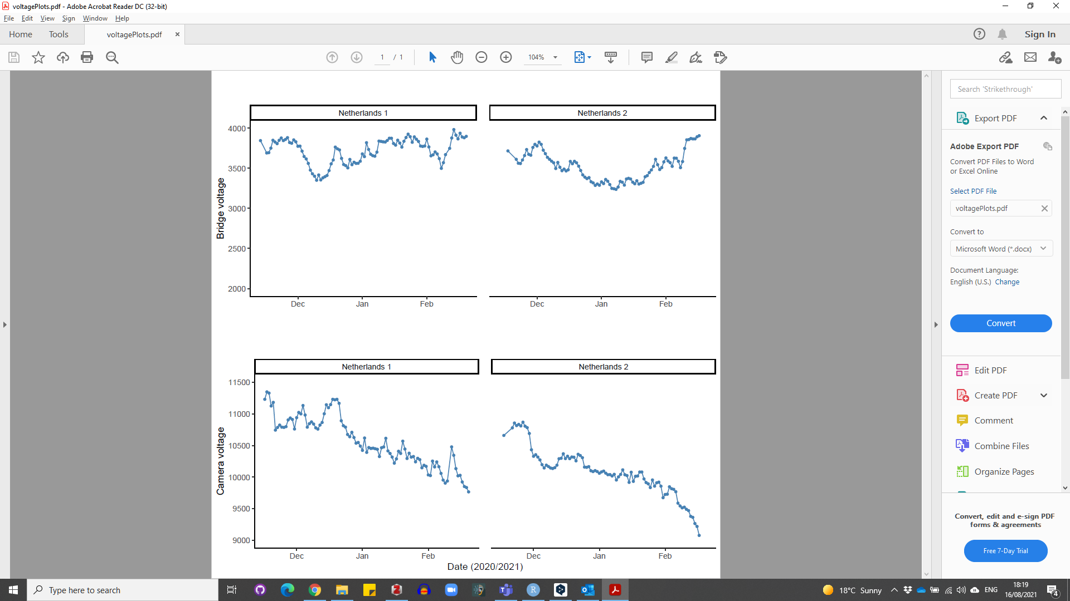

**Figure 4.** Smart bridge and camera voltage change over time during testing of two systems in the Netherlands using a solar panel.

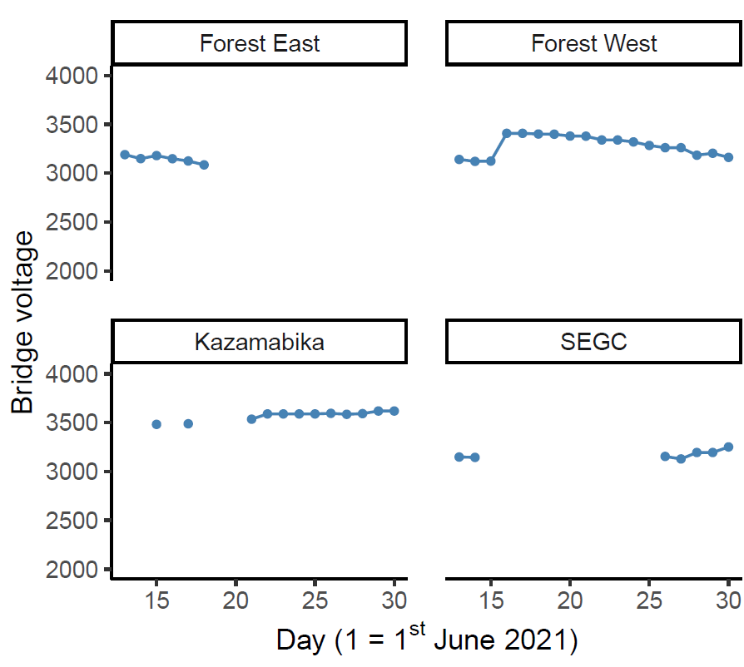

**Figure 5.** Smart bridge voltage changes over time during testing of four systems in Gabon using a solar panel.

*Artificial intelligence model accuracy and interpreting alerts*

Overall model accuracy on new data collected during the field test (*n* = 571 images) was 84%, with a Kappa statistic of 0.74. For the elephant class, precision was 82% and recall 86%, with a balanced accuracy of 86%. Test statistics for all classes and a confusion matrix are given in Table S4 and Figure S4. Classification of events using vote counting without any softmax thresholding (i.e. choosing the most frequently predicted class in a 30 minute time window) gave an overall performance of 78% and a Kappa statistic of 0.64 (*n* = 142 events) (Table S4). Excluding uncertain image labels using a softmax threshold before vote counting improved overall accuracy for event classification, as well as balanced accuracy for the elephant events (*n* = 29 true events, *n* = 30 predicted), which reached 98% at a threshold where images were excluded with a softmax value < 0.9 (Figure 6). This almost matched human accuracy with just one false positive event and no false negatives.

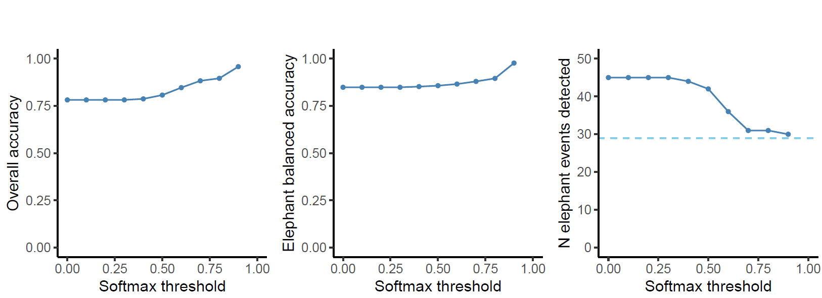

**Figure 6.** Effects of using a softmax threshold to exclude uncertain labels before vote counting to classify an event on (a) overall accuracy, (b) balanced accuracy for events labelled as elephant and (c) the number of elephant events detected (dashed horizontal line shows *n* = 29true events).

**Discussion**

Sending real-time alerts from ecological sensors such as camera traps in areas with poor data connectivity is complex and involves fine tuning a large number of software and hardware parameters. These include camera settings, camera positioning, achieving reliable network connectivity, training and running artificial intelligence models, interpreting and displaying artificial intelligence outputs and providing a reliable source of power. Our results demonstrate that these parameters can be tuned to achieve reliable, near real-time alerts from camera traps under challenging field conditions.

*Problems and solutions*

A total of 588 alerts were generated by our four systems during 18 days of field-testing, and the final total could have been as high as 814 if all alerts had been received. This is a substantial amount of data to interpret on a rolling basis with just four active systems and three label classes. In future, we recommend first implementing vote-counting combined with softmax thresholding on the smart bridge to reduce the total number of alerts, which would have been just 30 (with one false positive) if restricted only to elephants. This would not only improve alert accuracy but also reduce data transmission costs and will be implemented into future versions of the smart camera system.

Our system does not currently send images but this would be possible using an on-demand approach. For example, users could request certain images or an image series by sending a message (relayed via satellite) to the smart bridge. The main limitations to implementing this is achieving a reasonable trade-off between image quality and transmission cost. For example, sending an extremely compressed thumbnail (Figure S5) would cost $2 USD per image with a $20 per month contract on the Iridium network.

The next generation of camera traps will run artificial intelligence models on the camera hardware directly (known as ‘edge computing') instead of using a separate smart bridge. However, if the goal is to transmit real-time data from cameras installed near the ground for wildlife monitoring, then developers should be aware that it will be difficult to achieve network connectivity under a dense forest canopy. We were not able to send any images from Cayette forest patch, where the smart bridge was installed just 2 m above ground level. The wireless smart bridge, which can be mounted high in a tree, might therefore be a useful design feature for future edge computing solutions.

*Potential applications beyond our case study*

Our results show that we have created a viable hardware solution for running powerful artificial intelligence algorithms in the field and transmitting results over a satellite network. The computing power of the Raspberry Pi 4 is currently underused and there is scope for attaching other sensors, such as microphones for bioacoustic recording. There are already a substantial number of open-source Raspberry Pi projects available for ecological research, and many of these could be integrated with the smart bridge with relatively minimal effort (Jolles, 2021).

*Conclusion*

We have shown that it is possible to send reliable, real-time information from camera traps over the Iridium satellite network by integrating artificial intelligence, off-the-shelf and custom hardware. Our solution does not depend on installation of additional network infrastructure in the landscape and can be operated by non-experts from anywhere on earth.

**Acknowledgements**

Q42 funded hardware research and development costs. RCW was funded by the EU 11th FED ECOFAC6 program grant to the National Parks Agency of Gabon during data collection and curating of images used to train the artificial intelligence model, RCW, DMI and KAA received funding from the UK Research and Innovation’s Global Challenges Research Fund (UKRI GCRF) through the Trade, Development and the Environment Hub project (project number ES/S008160/1) during the field trials reported here. DL, NM, LM and BM were funded by the EU 11th FED ECOFAC6 program grant to the National Parks Agency of Gabon throughout all aspects of the study. The Ministry of the Environment, Water and Forests funded LJTW and co-funded fieldwork in Gabon. Appsilon funded the artificial intelligence model development costs. We thank Kelly Boekeeand Cisquet Kiebou Opepa for camera trap data made available by the Tropical Ecology Assessment and Monitoring Network (now [https://wildlifeinsights.org](https://wildlifeinsights.org/)). AC was funded by the Hertford College Mortimer May Fund at Oxford University. KAA and RCW received funding from forestLAB during the writing of this paper. We thank Smart Parks for the ability to build upon their open-source hardware designs and Irnas for the hardware development. We thank Hugh Robinson and Ross Pitman for early insights.

**Author contribution statement**

RCW contributed to the system design, co-wrote the manuscript, collected the data and analysed the data. TS designed the system, co-wrote the manuscript and collected data. TvD co-designed the system and collected data. JS created the AI model. HM co-designed the pilot. NM collected data. AFKP supervised RCW and contributed to writing the manuscript. JAZ, LB, AWC and BM supplied data for the AI model. SB supplied data for the AI model and co-wrote the manuscript. PH, CO and LJTW supplied data for the AI model and contributed to the system’s design. DL contributed to the system’s design and co-wrote the manuscript. LM collected data. DMI co-wrote the manuscript. KAA contributed to the manuscript and co-designed the pilot.

**Ethics statement**

The work was approved by the University of Stirling General University Ethics Panel, application number GUEP (2021) 1044.

**Research permissions**

The work was carried out in collaboration with the Tropical Ecology Research Institute in Gabon as part of the GCRF-TRADE Hub partnership

**Data availability statement**

*All data used in the analyses (excluding raw images) will be made publicly available on acceptance of the manuscript.*

**References**

Beery, S., Morris, D., Yang, S., Simon, M., Norouzzadeh, A., & Joshi, N. (2019). Efficient Pipeline for Automating Species ID in new Camera Trap Projects. *Biodiversity Information Science and Standards*, *3*, e37222. https://doi.org/10.3897/biss.3.37222

Bessone, M., Kühl, H. S., Hohmann, G., Herbinger, I., N’Goran, K. P., Asanzi, P., Costa, P. B. D., Dérozier, V., Fotsing, E. D. B., Beka, B. I., Iyomi, M. D., Iyatshi, I. B., Kafando, P., Kambere, M. A., Moundzoho, D. B., Wanzalire, M. L. K., & Fruth, B. (2020). Drawn out of the shadows: Surveying secretive forest species with camera trap distance sampling. *Journal of Applied Ecology*, *57*(5), 963–974. https://doi.org/10.1111/1365-2664.13602

Droissart, V., Azandi, L., Onguene, E. R., Savignac, M., Smith, T. B., & Deblauwe, V. (2021). PICT: A low-cost, modular, open-source camera trap system to study plant–insect interactions. *Methods in Ecology and Evolution*, *12*(8), 1389–1396. https://doi.org/10.1111/2041-210X.13618

Hill, A. P., Prince, P., Covarrubias, E. P., Doncaster, C. P., Snaddon, J. L., & Rogers, A. (2018). AudioMoth: Evaluation of a smart open acoustic device for monitoring biodiversity and the environment. *Methods in Ecology and Evolution*, *9*(5), 1199–1211. https://doi.org/10.1111/2041-210X.12955

Hobbs, M. T., & Brehme, C. S. (2017). *An improved camera trap for amphibians, reptiles, small mammals, and large invertebrates*. https://doi.org/10.1371/journal.pone.0185026

Jolles, J. W. (2021). Broad-scale applications of the Raspberry Pi: A review and guide for biologists. *Methods in Ecology and Evolution*, *n/a*(n/a). https://doi.org/10.1111/2041-210X.13652

Kuhn, M. (2020). caret: Classification and Regression Training. *R Package Version 6.0-86*. https://CRAN.R-project.org/package=caret

Leidig, M., & Teeuw, R. M. (2015). Quantifying and Mapping Global Data Poverty. *PLOS ONE*, *10*(11), e0142076. https://doi.org/10.1371/journal.pone.0142076

Norouzzadeh, M. S., Nguyen, A., Kosmala, M., Swanson, A., Palmer, M. S., Packer, C., & Clune, J. (2018). Automatically identifying, counting, and describing wild animals in camera-trap images with deep learning. *Proceedings of the National Academy of Sciences*, *115*(25), E5716–E5725. https://doi.org/10.1073/pnas.1719367115

Swanson, A., Kosmala, M., Lintott, C., & Packer, C. (2016). A generalized approach for producing, quantifying, and validating citizen science data from wildlife images. *Conservation Biology*, *30*(3), 520–531. https://doi.org/10.1111/cobi.12695

Tabak, M. A., Norouzzadeh, M. S., Wolfson, D. W., Sweeney, S. J., Vercauteren, K. C., Snow, N. P., Halseth, J. M., Salvo, P. A. D., Lewis, J. S., White, M. D., Teton, B., Beasley, J. C., Schlichting, P. E., Boughton, R. K., Wight, B., Newkirk, E. S., Ivan, J. S., Odell, E. A., Brook, R. K., … Miller, R. S. (2019). Machine learning to classify animal species in camera trap images: Applications in ecology. *Methods in Ecology and Evolution*, *10*(4), 585–590. https://doi.org/10.1111/2041-210X.13120

Wearn, O. R., & Glover-Kapfer, P. (2019). Snap happy: Camera traps are an effective sampling tool when compared with alternative methods. *Royal Society Open Science*, *6*(3), 181748. https://doi.org/10.1098/rsos.181748

Whytock, R. C., Świeżewski, J., Zwerts, J. A., Bara‐Słupski, T., Pambo, A. F. K., Rogala, M., Bahaa‐el‐din, L., Boekee, K., Brittain, S., Cardoso, A. W., Henschel, P., Lehmann, D., Momboua, B., Opepa, C. K., Orbell, C., Pitman, R. T., Robinson, H. S., & Abernethy, K. A. (2021). Robust ecological analysis of camera trap data labelled by a machine learning model. *Methods in Ecology and Evolution*, *12*(6). https://doi.org/10.1111/2041-210X.13576